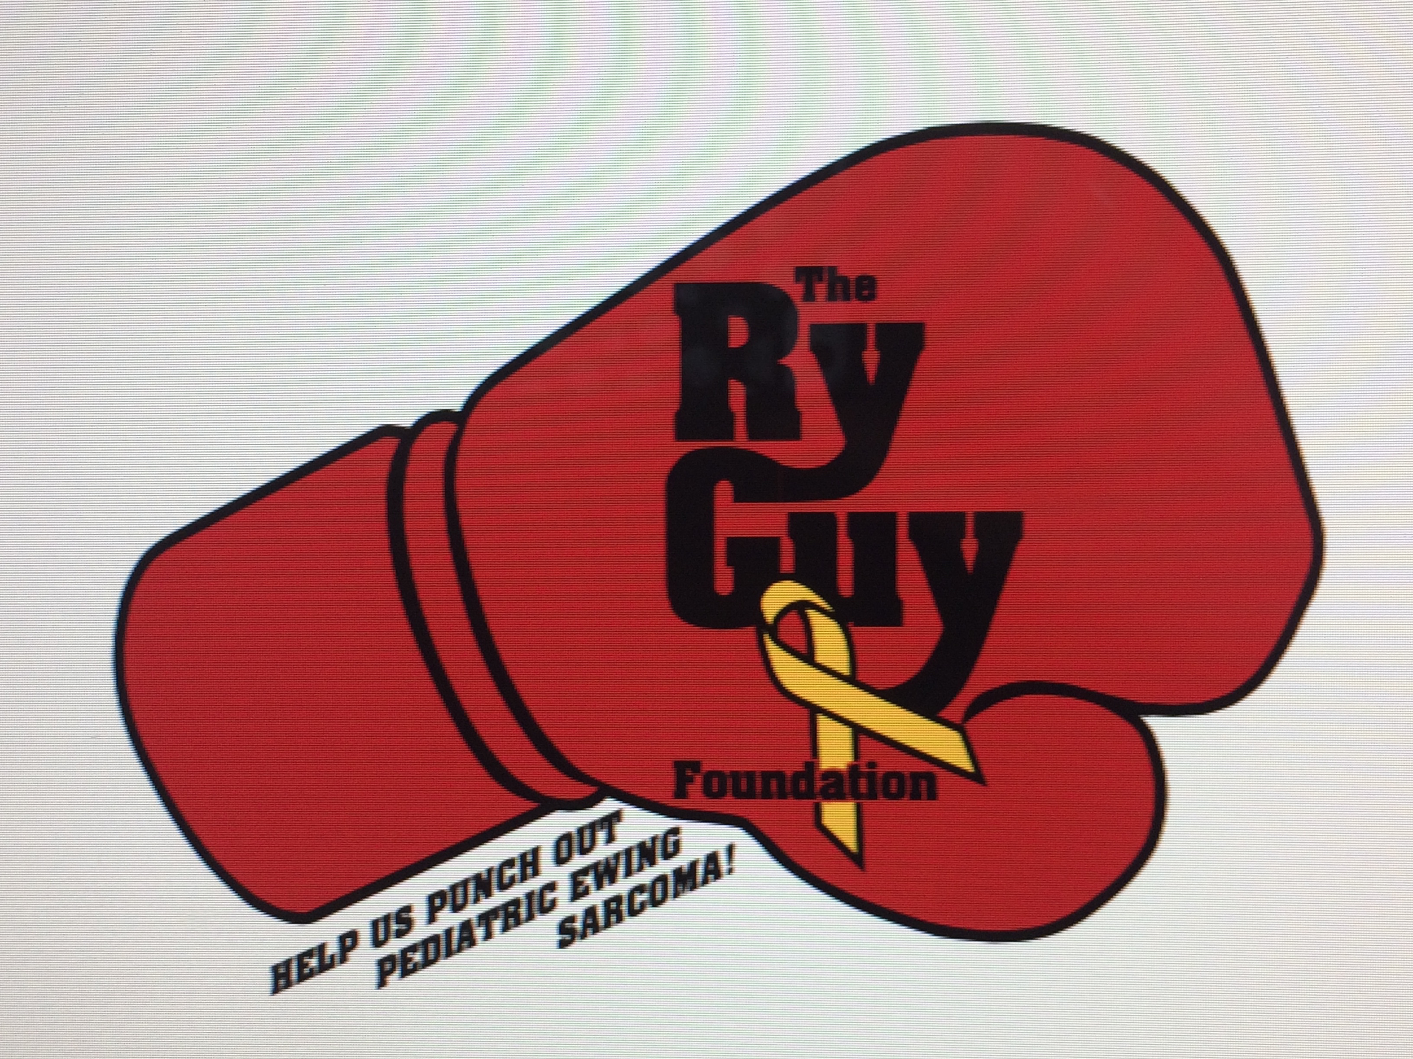

Dear Supporter,

Thank you for making a contribution to
The Ry Guy Foundation. Your support will help fund critical pediatric cancer research. 43 children are diagnosed with cancer each day and need our help. By supporting The Ry Guy Foundation, you are part of a movement that has the ability to change the future of pediatric cancer. We look to the success of the future with great hope, knowing that each day we are making strides to provide a healthier, brighter future for kids and their families.

You are helping us Punch Out Pediatric Cancer!
Thanks for Ry’s (ing) Up!

The Ry Guy Foundation
(In memory of Ryan Baker)
www.theryguyfoundation.com

